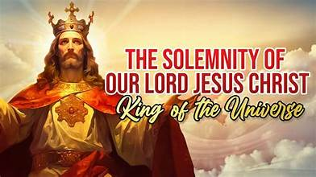
Saint John the Baptist Parish Parroquia San Juan Bautista
The Destruction of the Temple and Signs of the End Times
Luke 21:5-19
69 QUINCY AVE., PAWTUCKET, RI 02860
Rev. Mauricio Romero Víquez, Pastor
Vicente Caban, Deacon
Robert Giambo, Organist
Mrs. Cecilia Marín-Hoyt, Secretary
Email stjohnbaptist.org@gmail.com www.churchofstjohnthebaptist.org

Office Hours
Horario de la Oficina
Monday – Thursday / Lunes a Jueves
9:00am - 2:00pm 401-722-9054

Weekend Masses
Misas de fin de semana
Saturday: 4:30pm English / Inglés
Sábado 6:00pm Español / Spanish
Sunday: 9:30am English / Inglés
Domingo 11:30am Español / Spanish

Daily Masses
Misas durante la semana
Wednesday 8:00am English / Inglés
Martes y Viernes 7:00pm Español / Spanish
Bilingual Mass Saturday / Sábado at 8:00am

Confessions (Chapel) / Confessions (Capilla)
Saturday / Sábado 3:30pm to 4:20pm
& 5:30pm to 5:50pm or by apt. / por cita

Baptism / Bautismo
Baptisms are celebrated on the second Sunday of every Month after the 11:30am Mass. Please call the rectory at least two months in advance.
Los Bautismos se celebran el segundo Domingo de cada mes después de la Misa de las 11:30am. Llame a la rectoría con 2 meses de anticipación.

Anointing of the Sick
Unción de los enfermos
Please call the parish.
Por favor llamar a la parroquia.

Legión de María
Lunes a las 6:00pm en la Sacristía
Matrimony / Matrimonio
Call one year in advance to begin preparation. Llamar con un año de anticipación.

Eucharistic Adoration
Adoración Eucarística
Every Friday / Todos los Viernes
9:00am to 6:45pm in the Church / en la Iglesia

Young Women’s Faith Group
Ages / Edades 15 to 25
Meeting Place: Rectory
1st Sunday of the month from 6-8pm

Chiquitin Misionero
Wednesdays / Miercoles 6 – 7:30pm
5 to 7 years old / Niños de 5 a 7 años

Comunidad Evangelizadora (CERS)
Miércoles a las 7:30pm en el sótano

Food Bank / Banco de Comida
November / Noviembre
Monday / Lunes 17 & 24
9:30am to 11:00am & 6:00pm to 7:00pm
Wednesday / Miercoles 19 & 26
9:30am to 11:00am

Hospitality House / Casa de Hospitalidad
Open every Tuesday / Martes at 10:30am
Hot lunch / Almuerzo caliente at 11:30 am

New Parishioners
Please call the Rectory to register.
Llamar a la Rectoría para registrarse.
Dear Parishioners,
Happy and Blessed First Sunday of Advent! The season of Advent begins a new liturgical year in
the Catholic Church. Therefore, it is a great time for each of us to “begin again” as we spiritually
prepare to celebrate the Birth of Jesus on Christmas Day, as well as prepare each day to welcome
Jesus Christ into our lives. Here are “Ten Ways to Get More out of Advent” by
Lorene Hanley Duquin (10/7/2013): “(1) Reect on Advent as a time of
Dear Parishioners,
Happy and Blessed First Sunday of Advent! The season of Advent begins a new liturgical year in
the Catholic Church. Therefore, it is a great time for each of us to “begin again” as we spiritually
prepare to celebrate the Birth of Jesus on Christmas Day, as well as prepare each day to welcome
Jesus Christ into our lives. Here are “Ten Ways to Get More out of Advent” by
Lorene Hanley Duquin (10/7/2013): “(1) Reect on Advent as a time of
brothers and sisters, may this season of Advent be fruitful for each one of us. God Bless!
Fr. Sistare
IMPORTANT NOTE: During this time of A
Dear Parishioners,
Happy and Blessed First Sunday of Advent! The season of Advent begins a new liturgical year in the Catholic Church. Therefore, it is a great time for each of us to “begin again” as we spiritually prepare to celebrate the Birth of Jesus on Christmas Day, as well as prepare each day to welcome Jesus Christ into our lives. Here are “Ten Ways to Get More out of Advent” by Lorene Hanley Duquin (10/7/2013): “(1) Reflect on Advent as a time of waiting. The idea of waiting is not popular in our culture of instant gratification, but it creates in us a new kind of self-discipline that helps us to appreciate the present moment and look to the future with peaceful anticipation. (2) Turn your breathing into a prayer. Take a few deep breaths throughout the day and imagine that God's love is flowing through you to every part of your body. As you exhale, let go of tension, worry and anything else that is not of God. (3) Long for the Lord. Make it a habit of silently praying, "Come, Lord Jesus.” (4) Unite with Mary. Set aside time once a day to join Our Lady in praying the Canticle of Mary (see Lk 1:46-55). (5) Do something nice for someone every day. It might be an encouraging word, a phone call, a note of appreciation or a little act of kindness. (6) Get rid of grudges. Use Advent as an opportunity to let go of any anger or resentment that you might be holding onto. (7) Pray for patience. If you find yourself becoming anxious or upset, ask the Lord for the gift of patience. Then make a conscious effort to be a more patient person. (8) Offer up something painful or difficult in your life. The best way to transform trials and tensions is to turn them into a prayer. (9) Receive the Sacrament of Reconciliation. Take advantage of the opportunity to cleanse your soul in preparation for the coming of Jesus. (10) Think about the special gifts and talents God has given you. How are you using these gifts?” My brothers and sisters, may this season of Advent be fruitful for each one of us. God Bless!
Fr. SistaDear Parishioners,
Happy and Blessed First Sunday of Advent! The season of Advent begins a new liturgical year in the Catholic Church. Therefore, it is a great time for each of us to “begin again” as we spiritually prepare to celebrate the Birth of Jesus on Christmas Day, as well as prepare each day to welcome Jesus Christ into our lives. Here are “Ten Ways to Get More out of Advent” by Lorene Hanley Duquin (10/7/2013): “(1) Reflect on Advent as a time of waiting. The idea of waiting is not popular in our culture of instant gratification, but it creates in us a new kind of self-discipline that helps us to appreciate the present moment and look to the future with peaceful anticipation. (2) Turn your breathing into a prayer. Take a few deep breaths throughout the day and imagine that God's love is flowing through you to every part of your body. As you exhale, let go of tension, worry and anything else that is not of God. (3) Long for the Lord. Make it a habit of silently praying, "Come, Lord Jesus.” (4) Unite with Mary. Set aside time once a day to join Our Lady in praying the Canticle of Mary (see Lk 1:46-55). (5) Do something nice for someone every day. It might be an encouraging word, a phone call, a note of appreciation or a little act of kindness. (6) Get rid of grudges. Use Advent as an opportunity to let go of any anger or resentment that you might be holding onto. (7) Pray for patience. If you find yourself becoming anxious or upset, ask the Lord for the gift of patience. Then make a conscious effort to be a more patient person. (8) Offer up something painful or difficult in your life. The best way to transform trials and tensions is to turn them into a prayer. (9) Receive the Sacrament of Reconciliation. Take advantage of the opportunity to cleanse your soul in preparation for the coming of Jesus. (10) Think about the special gifts and talents
Dear Parishioners,
Happy and Blessed First Sunday of Advent! The season of Advent begins a new liturgical year in the Catholic Church. Therefore, it is a great time for each of us to “begin again” as we spiritually prepare to celebrate the Birth of Jesus on Christmas Day, as well as prepare each day to welcome Jesus Christ into our lives. Here are “Ten Ways to Get More out of Advent” by Lorene Hanley Duquin (10/7/2013): “(1) Reflect on Advent as a time of waiting. The idea of waiting is not popular in our culture of instant gratification, but it creates in us a new kind of self-discipline that helps us to appreciate the present moment and look to the future with peaceful anticipation. (2) Turn your breathing into a prayer. Take a few deep breaths throughout the day and imagine that God's love is flowing through you to every part of your body. As you exhale, let go of tension, worry and anything else that is not of God. (3) Long for the Lord. Make it a habit of silently praying, "Come, Lord Jesus.” (4) Unite with Mary. Set aside time once a day to join Our Lady in praying the Canticle of Mary (see Lk 1:46-55). (5) Do something nice for someone every day. It might be an encouraging word, a phone call, a note of appreciation or a little act of kindness. (6) Get rid of grudges. Use Advent as an opportunity to let go of any anger or resentment that you might be holding onto. (7) Pray for patience. If you find yourself becoming anxious or upset, ask the Lord for the gift of patience. Then make a conscious effort to be a more patient person. (8) Offer up something painful or difficult in your life. The best way to transform trials and tensions is to turn them into a prayer. (9) Receive the Sacrament of Reconciliation. Take advantage of the opportunity to cleanse your soul in preparation for the coming of Jesus. (10) Think about the special gifts and talents
Dear Parishioners,
The season of summer is officially underway, as we can tell with the higher
temperatures outside. The following beautiful reflection and summer prayer can
help us reflect on how important our relationship with the Lord should be every
day in our lives.
Summer Reflection
“All of us have so much to be thankful for each day. When we awake to a new day,
when a friend is in touch with us, for the food we eat, for the water that flows into
our homes, for flowers, birds, trees, our health, for doctors close by who care for
us: the list can go on and on. Thanking God should be part of our daily lives. It is
also good to tell God about worries and concerns: about jobs, relationships,
family, health, whatever comes to mind. Sharing those thoughts with God will often
help to lessen the burdens we carry. Take time -- lots of it -- each day to talk to
God in prayer. If you spend time with family members or friends, engage them in
prayer with you, and listen to how they share their joys/concerns/thanks with
God.”
Summer Prayer
“Creator of all, thank You for summer! Thank You for the warmth of the sun and
the increased daylight. Thank You for the beauty I see all around me and for the
opportunity to be outside and enjoy Your creation. Thank You for the increased
time I have to be with my friends and family, and for the more casual pace of the
summer season. Draw me closer to You this summer. Teach me how I can pray no
matter where I am or what I am doing. Warm my soul with the awareness of Your
presence, and light my path with Your Word and Counsel. As I enjoy Your
creation, create in me a pure heart and a hunger and a thirst for You. Amen.”
Dear Parishioners,
The season of summer is officially underway, as we can tell with the higher
temperatures outside. The following beautiful reflection and summer prayer can
help us reflect on how important our relationship with the Lord should be every
day in our lives.
Summer Reflection
“All of us have so much to be thankful for each day. When we awake to a new day,
when a friend is in touch with us, for the food we eat, for the water that flows into
our homes, for flowers, birds, trees, our health, for doctors close by who care for
us: the list can go on and on. Thanking God should be part of our daily lives. It is
also good to tell God about worries and concerns: about jobs, relationships,
family, health, whatever comes to mind. Sharing those thoughts with God will often
help to lessen the burdens we carry. Take time -- lots of it -- each day to talk to
God in prayer. If you spend time with family members or friends, engage them in
prayer with you, and listen to how they share their joys/concerns/thanks with
God.”
Summer Prayer
“Creator of all, thank You for summer! Thank You for the warmth of the sun and
the increased daylight. Thank You for the beauty I see all around me and for the
opportunity to be outside and enjoy Your creation. Thank You for the increased
time I have to be with my friends and family, and for the more casual pace of the
summer season. Draw me closer to You this summer. Teach me how I can pray no
matter where I am or what I am doing. Warm my soul with the awareness of Your
presence, and light my path with Your Word and Counsel. As I enjoy Your
creation, create in me a pure heart and a hunger and a thirst for You. Amen.”
Dear Parishioners,
The season of summer is officially underway, as we can tell with the higher
temperatures outside. The following beautiful reflection and summer prayer can
help us reflect on how important our relationship with the Lord should be every
day in our lives.
Summer Reflection
“All of us have so much to be thankful for each day. When we awake to a new day,
when a friend is in touch with us, for the food we eat, for the water that flows into
our homes, for flowers, birds, trees, our health, for doctors close by who care for
us: the list can go on and on. Thanking God should be part of our daily lives. It is
also good to tell God about worries and concerns: about jobs, relationships,
family, health, whatever comes to mind. Sharing those thoughts with God will often
help to lessen the burdens we carry. Take time -- lots of it -- each day to talk to
God in prayer. If you spend time with family members or friends, engage them in
prayer with you, and listen to how they share their joys/concerns/thanks with
God.”
Summer Prayer
“Creator of all, thank You for summer! Thank You for the warmth of the sun and
the increased daylight. Thank You for the beauty I see all around me and for the
opportunity to be outside and enjoy Your creation. Thank You for the increased
time I have to be with my friends and family, and for the more casual pace of the
summer season. Draw me closer to You this summer. Teach me how I can pray no
matter where I am or what I am doing. Warm my soul with the awareness of Your
presence, and light my path with Your Word and Counsel. As I enjoy Your
creation, create in me a pure heart and a hunger and a thirst for You. Amen.”

Solemnity of Our Lord Jesus Christ King of the Universe
November 23, 2025

Peace and all good, dear brothers and sisters in our Lord Jesus Christ.

The year was 1925. Pius XI, concerned about the growing cultural secularism and with the desire that the world, recognizing the sovereignty of Jesus, might enjoy freedom, tranquility, peace, and harmony, instituted this feast, which began as Christ the King and which, in the liturgical reform of the Second Vatican Council, became Christ the King of the Universe. Personally, this feast is one of the most beautiful of the liturgical year for me, for we celebrate Jesus Christ, King of the Universe. Who chose the Cross as his throne and a crown of thorns as his crown, not one of precious gems (like the other kings of that time)? The evangelist Saint John highlights, in the context of Pilate's interrogation, when Pilate asks Jesus, "You are the King of the Jews?" (Jn. 18:33), Jesus answered, "You say that I am a king. For this I was born, and for this I came into the world, to bear witness to the truth" (Jn. 18:37). This response of Jesus is significant, for he stands before the Roman authority and is not at all afraid to present himself as King, for as the Gospel of Saint John says, "My kingdom is not of this world" (Jn. 18:36); it is a kingdom different from that of other nations. Because no one could believe that a king could be scourged, crowned with thorns, mocked by Roman soldiers, carry a cross, and finally die between two criminals (out of love for humanity). And one of them (robbers), Saint Luke tells us (Gospel of cycle C, liturgical year 10), was crucified. 2025), “Jesus, remember me when you come into your kingdom.” Jesus said to him, “Truly I tell you, today you will be with me in paradise” (Lk 25:43).

The title “Christ the King” has its roots in both Scripture and the theology of the Kingdom of God. In most of the messianic prophecies, recorded in the Old Testament books of Samuel, Isaiah, Jeremiah, and Daniel, Christ the Messiah is presented as King.

a) In the Annunciation, recorded in Luke 1:32-33, we read: “…and the Lord God will give him the throne of his father David, and he will reign over

the house of Jacob forever; his kingdom will never end.” In fact, the Kingdom of God is central to Jesus’ teaching, and the phrase “Kingdom of God” appears 122 times in the Gospels, 90 of them used by Jesus.

b) The Magi arrived in Jerusalem and asked: (Mt. 2, 2) “Where is the child who is to be born King of the Jews? We saw his star… and have come to worship him.”

c) During the royal reception offered to Jesus on Palm Sunday, the Jews shouted: (Lk. 19:38) “Blessed is the King who comes in the name of the Lord!”

d) During Jesus’ trial, described in today’s Gospel, Pilate asked him: “Are you the King of the Jews?” (Jn 18:33), and Jesus answered, “You say so: I am a king. For this I was born, and for this I have come into the world, to testify to the truth” (Jn 18:37).

e) The sign that hung above Jesus’ head on the cross read: “Jesus of Nazareth, King of the Jews.”

f) Before his Ascension into Heaven, Jesus declared, “All authority in heaven and on earth has been given to me. Therefore, go and make disciples of all nations…” (Mt 28:18).

g) Finally, in Matthew 25:31, we read that Christ the King will come in glory to judge us on the Day of Judgment.

The Gospel we meditate on this Solemnity of Christ the King of the Universe (Saint Luke) does not understand Jesus’ death as a failure. And it is not, in truth. It is the supreme moment of surrender to a cause for which he deserves to give his life. When all those around him… Those who challenged him from the cross to offer salvation according to their understanding of it, and Jesus refused. When someone, broken, even if he was a thief, begs him, pleads with him, begs him, offers him everything he is and everything he has. From his powerlessness as the crucified one, yet as the true Lord, he offers forgiveness, mercy, and salvation. This theology of

the cross is key to properly understanding Jesus Christ as King of the universe. He is a king without power, that is, the "powerlessness" of love, truth, and the Gospel as good news for all who need his help. "Today you will be with me in paradise" (Luke 25:43) is the most resounding affirmation of what this crucified king truly offers. It is not the conquest of the world, but of our own life beyond this world.
" LONG LIVE JESUS ​​CHRIST, KING OF THE UNIVERSE!" This was the cry of the Cristeros (Mexican Catholics who fought against the anti-clerical laws of 1926 and 1937). 1929), in Mexico where thousands died bearing witness to Jesus Christ, King of the Universe. May we all today proclaim with one voice: LONG LIVE JESUS ​​CHRIST, KING OF THE UNIVERSE!

MASS INTENTIONS
Saturday November 22 4:30pm
+Birthday remembrance of Donald Theroux, by Gail Theroux
Sunday November 23 9:30am
+Philomene Mianoh, by Amadi Family
Wednesday November 25 8:00am
+The members of the Levesque Family, by Rose Marie Dujardin
Thanksgiving Day bilingual Mass
Thursday November 26 9:30am
Saturday November 29 4:30pm
+Nelson Carreiro & Joseph Placido, by his wife Rosemary
Sunday November 30 Bilingual 11:30am
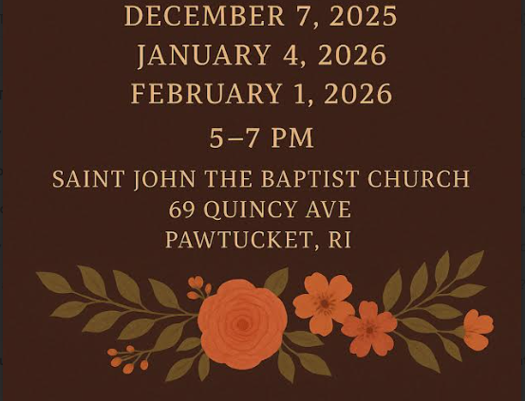
Installation Mass with Bishop Bruce Lewandowski

Collection 11/16 $4378.00
Second Collection
Human Development 11/23
Retirement Fund for Religious 12/14
Fuel/Maintenance 12/28

WE ASK FOR YOUR PRAYERS
For the following parishioners:
In the Hospital: Hope Fernandes
At Home: Jovina De Barros, Joyce Lagesse & Roberto Mejía
Jeanne Jugan Residence: Florence Corneau
Grandview: Alberto De Barros

Saint Joseph’s Vigil Candle
For the eternal rest of Philomene Mianoh
By the Amadi Family



Make a gift affirming the sanctity of human life. Please fill the baby bottles with coins, cash or checks and return them to the church by November 27 & 28. The Baby Bottle Boomerang Campaign is used to fund Rhode Island’s Right to Life Services, a ministry that helps pregnant women, newborns and toddlers throughout R.I., with material needs, referrals, emer-gency baby food/formula, and with Ancora, a free mobile ultrasound pregnancy center. There will be a collection bin located in the back of the church for when you return the bottles.
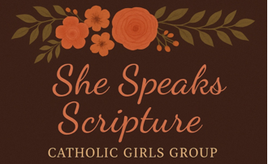

Announcements
Masses on Wednesday and Saturday 8am will now be celebrated in the Chapel. The donation is $10 on weekdays and $20 on weekends for each Mass.

Faith Formation Class Schedule
November 26 – No class
December 3, 10, 17 – Class
Time 6:00 to 7:30pm
In the Church Hall, please enter thru Bullock St.

The Installation Mass
It will take place on November 30th at 11:30am. It will be a bilingual Mass. There will be no 9:30am Mass. The intention will be for the needs of our new pastor, Father Mauricio Romero Víquez.

St. John the Baptist Parish Christmas Bazaar
The Christmas Bazaar will take place in the parish hall on Saturday, December 6, from 10am to 7pm and Sunday December 7, from 10:00am to 2:00pm (ticket sales end at 1:45 pm on Sunday The bazaar will feature raffles, food, plants, jewelry, baked goods, personalized t-shirts, themed raffle baskets, and much more. The venue is not accessible to people with disabilities.

O Jesus Christ, I acknowledge you as universal King. All that has been made has been created for You. Exercise all Your rights over me. I renew my Baptismal Vows. I renounce Satan, his pomps and his works; I promise to live as a good Christian. And, in particular do I pledge myself to labor, to the best of my ability, for the triumph of the rights of God and of Your Church. Divine Heart of Jesus, to You do I offer my poor services, laboring that all hearts may acknowledge Your sacred kingship, and that thus the reign of Your peace be established throughout the whole universe. Amen.

Saint John the Baptist Parish Raffle
Prizes
1st: $500 2nd: $250
3rd: $150 4th: $100
Drawing will take place during the Christmas Bazaar December 6 & 7
$5.00 Each Ticket

Anuncios

Las Misas de los miércoles y sábados 8am se celebrarán en la Capilla. La donacion es de $10 entre semana y $20 el fin de semana por cada Misa.

Horario de Clases de Formación de Fe
Noviembre 26 – No hay clase
Diciembre 3, 10, 17 - Hay clase
De las 6:00 a las 7:30pm En el sótano de la Iglesia, entrar por la calle Bullock.

La misa de instalación tendrá lugar el 30 de noviem-bre a las 11:30 a.m. Será una misa bilingüe. No habrá misa a las 9:30 a.m. La intención será por las necesidades de nuestro nuevo párroco, el padre Mauricio Romero Víquez.

Bazar Navideño de la Parroquia de San Juan Bautista
El bazar navideño tendrá lugar en el salón parroquial el sábado 6 de diciembre, de 10:00am a 7:00pm, y el domingo 7 de diciembre, de 10:00am a 2:00pm (la venta de boletos finaliza a la 1:45 del domingo). En el
bazar habrá rifas, venta de comida, plantas, joyería, repostería, camisetas personalizadas, cestas temáticas para rifas y mucho más. El local no es accesible para personas con discapacidad.

Celebración de Nuestra Señora de Guadalupe
La Misa diocesana a Nuestra Sra. de Guadalupe se llevará a cabo el viernes 12 de diciembre a las 7:00pm en la Catedral de San Pedro y San Pablo, el Celebrante y Homilista será Su Excelencia Reverendísima Bruce A. Lewandowski, C.Ss.R. Obispo de Providence. Comenzaremos 5:30 p.m. con el rezo del Rosario, habrá confesiones y una serenata a la Virgen previo a la Misa. ¡Pasa la voz, invita a tus familiares y amigos!

Parroquia de San Juan Bautista Rifa
Premios
1º: $500 2º: $250
3º: $150 4º: $100
El sorteo se llevará a cabo durante el Bazar de Navidad – Diciembre 6 y 7 $5.00 cada boleta

Solemnidad de Nuestro Señor Jesucristo Rey del Universo
23 de Noviembre, 2025

¡Paz y Bien!, estimados hermanos y hermanas en nuestro Señor Jesucristo.
Corría el año 1925. Pio XI, inquieto por el creciente laicismo cultural y con el deseo de que el mundo, reconociendo la soberanía de Jesús, pudiese disfrutar la libertad, la tranquilidad, la paz y la concordia, instituyó esta fiesta que comenzó llamándose de Cristo Rey y que en la reforma litúrgica del Concilio Vaticano II pasó a ser de Jesucristo Rey del Universo.

En lo particular esta fiesta para mí es de las más hermosas del año litúrgico, pues celebramos a Jesucristo Rey del Universo. ¿Quién?, escogió por trono la Cruz y por Corona una de espinas y no de gemas preciosas (cómo los demás reyes de la época). El evangelista San Juan, resalta ante el interrogatorio de Pilato, ¿cuándo éste pregunta?, a Jesús: “Tú eres rey de los judíos” (Jn. 18, 33),“Jesús respondió: «Tú lo dices: soy rey. Para esto he nacido y para esto he venido al mundo: para dar testimonio de la verdad» (Jn. 18, 37). Es significativo esta respuesta de Jesús, pues él, se haya delante de la autoridad romana y no teme, en absoluto, de presentarse como Rey, pues como dice el evangelio de San Juan: “Mi reino no es de este mundo” (Jn. 18, 36), es un reino diferente de las otras naciones. Porque nadie podría creer que un rey, pudiese ser azotado, coronado de espinas, recibir burlas de los soldados romanos, cargar un madero y finalmente morir en medio de dos malhechores (por amor a la humanidad). Y uno de ellos (ladrones), nos dice San Lucas (evangelio del ciclo C año litúrgico 2025), «Jesús, acuérdate de mí cuando llegues a tu reino». Jesús le dijo: «En verdad te digo: hoy estarás conmigo en el paraíso» (Lc. 25, 43).

El título «Cristo Rey» tiene sus raíces tanto en las Escrituras como en la teología del Reino de Dios. En la mayoría de las profecías mesiánicas, recogidas en los libros del Antiguo Testamento de Samuel, Isaías, Jeremías y Daniel, Cristo el Mesías es presentado como Rey.

a) En la Anunciación, registrada en Lucas 1: 32-33, leemos: «…y el Señor Dios le dará el trono de David, su padre, y reinará sobre la casa de Jacob para siempre; y su reino no tendrá fin». De hecho, el

Reino de Dios es el centro de la enseñanza de Jesús, y la frase «Reino de Dios» aparece 122 veces en los Evangelios, 90 de ellas utilizadas por Jesús.

b) Los Reyes Magos llegaron a Jerusalén y preguntaron: (Mt. 2, 2) «¿Dónde está el niño que ha de nacer como Rey de los judíos? Vimos su estrella… y hemos venido a adorarlo».

c) Durante la recepción real que se le ofreció a Jesús el Domingo de Ramos, los judíos gritaron: (Lc. 19, 38) «¡Bendito sea el Rey que viene en el nombre del Señor!»

d) Durante el juicio de Jesús, descrito en el Evangelio de hoy, Pilato le preguntó: «¿Eres tú el rey de los judíos?» (Jn 18,33), y Jesús respondió: «Tú lo dices: soy rey. Para esto he nacido y para esto he venido al mundo: para dar testimonio de la verdad» (Jn 18,37).

e) El letrero que colgaba sobre la cabeza de Jesús en la cruz decía: «Jesús de Nazaret, Rey de los Judíos».

f) Antes de su Ascensión al Cielo, Jesús declaró: «Se me ha dado toda autoridad en el cielo y en la tierra; por tanto, vayan y hagan discípulos de todas las naciones…» (Mt. 28, 18).

g) Finalmente, en Mateo 25, 31, leemos que Cristo el Rey vendrá con gloria para juzgarnos el día del Juicio Final.

El evangelio que meditamos en esta Solemnidad de Jesucristo Rey del Universo, (San Lucas), no entiende la muerte de Jesús como un fracaso. Y no lo es en verdad. Es el momento supremo de la entrega a una causa por la que merece dar la vida. Cuando todos los que están al lado de la cruz le han retado a que se salve tal como ellos entienden la salvación, Jesús se niega a aceptarlo. Cuando alguien, destrozado, aunque haya sido un ladrón, le ruega, le pide, le suplica, ofrece todo lo que es y todo lo que tiene. Desde su impotencia de crucificado, pero de Señor verdadero, ofrece perdón, misericordia y salvación. Esta teología de la cruz es la clave para entender adecuadamente a Jesucristo como Rey del universo. Es un rey sin

poder, es decir, el “sin-poder” del amor, de la verdad y del evangelio como buena nueva para todos los que necesitan su ayuda. “Hoy estarás conmigo en el paraíso” (Lc. 25, 43), es la afirmación más rotunda de lo que este rey crucificado ofrece de verdad. No es
la conquista del mundo, sino de nuestra propia vida más allá de este mundo.

VIVA ¡JESUCRISTO REY DEL UNIVERSO!, este fue el grito de los llamados cristeros (católicos mexicanos que lucharon contras las leyes anticlericales 1926 y 1929), en México donde miles murieron testimoniando a Jesucristo Rey del Universo. Que todos hoy aclamemos a una sola voz: VIVA ¡JESUCRISTO REY DEL UNIVERSO!

INTENCIONES DE LAS MISAS
Sábado 22 de noviembre Vigilia 6:00pm
En acción de gracias por el cumpleaños de Carolina Torres
Por las necesidades de la familia Tamayo Velas-quez, intención de Lucia Tamayo
+Por el eterno descanso de María Eugenia Hernán-dez, intención de sus hermanos y sobrinos
+Por el eterno descanso de Luis Eduardo Buritica, intención de Esmeralda Buritica
+Por el eterno descanso de Luis Eduardo Idarraga y Margarita Castaño, intención de sus hijas
+Por el eterno descanso de Antonio José Guerra Figueroa, intención de la familia Carrera Guerra
Domingo 23 de noviembre 11:30am
+Por el eterno descanso de Alicia Echeverry & Jordan Berson, intención de la familia Durango
+Por el eterno descanso de Mayra Valiente, Marilyn Pérez Fuentes, Ariel Quintero, intención de la familia Valiente
+Por el eterno descanso de María Eugenia Hernán-dez, intención de sus hermanos y sobrinos
+Por el eterno descanso de María de Lourdes Andrade, Domingo Correia, Zelita Correia, Dulce Gomes Barros, intención de Helena Barros
+Por el eterno descanso de Jose Correia Mendes, intención de Alice Goncalves
+Por el eterno descanso de Antonio José Guerra Figueroa, intención de la familia Carrera Guerra
+Por las Benditas Almas del Purgatorio

Martes 25 de noviembre 7:00pm
+Por el eterno descanso de Antonio Guerra José Figueroa, intención de la familia Carrera Guerra
+Por las Benditas Almas del Purgatorio
Día de Acción de Gracias Misa Bilingüe
Jueves Noviembre 26 9:30am
Viernes 28 de noviembre 7:00pm
+Por el eterno descanso de Antonio José Guerra Figueroa, intención de la familia Carrera Guerra
+Por las Benditas Almas del Purgatorio
Sábado 29 de noviembre (Misa Bilingüe) 8:00am
+Por el eterno descanso de Antonio José Guerra Figueroa, intención de la familia Carrera Guerra
+Por las Benditas Almas del Purgatorio
Vigilia 6:00pm
+Por el eterno descanso de María Eugenia Hernán-dez, intención de sus hermanos y sobrinos
+Por el eterno descanso de Adelfa Pérez, intención de su hijo y nietos
+Por el eterno descanso de Olga Zapata, intención de su familia
+Por el eterno descanso de Antonio José Guerra Figueroa, intención de la familia Carrera Guerra
Domingo 30 de noviembre 11:30am
En acción de gracias por el nuevo párroco

Colecta 11/16 $4378.00
Segunda Colecta Desarrollo Humano 11/23 Fondo de jubilación para religiosos 12/14
Gas/Mantenimiento 12/28

Haga un regalo que afirme la santidad de la vida humana. Por favor, llene las botellas de bebe con monedas, efectivo o cheques y devuélvalas a la iglesia antes del 27 y 28 de noviembre. La Campaña Baby Bottle Boomerang se utiliza para financiar los Servicios de Derecho a la Vida de Rhode Island, un ministerio que ayuda a las mujeres embarazadas, recién nacidos y niños pequeños en todo Rhode Island, con necesidades materiales, referencias, alimentos/fórmula de emergencia para bebés, y con Ancora, un centro de embarazo con ultrasonido móvil gratuito. Habrá un contenedor de recolección ubicado en la parte trasera de la iglesia para cuando devuelva las botellas.

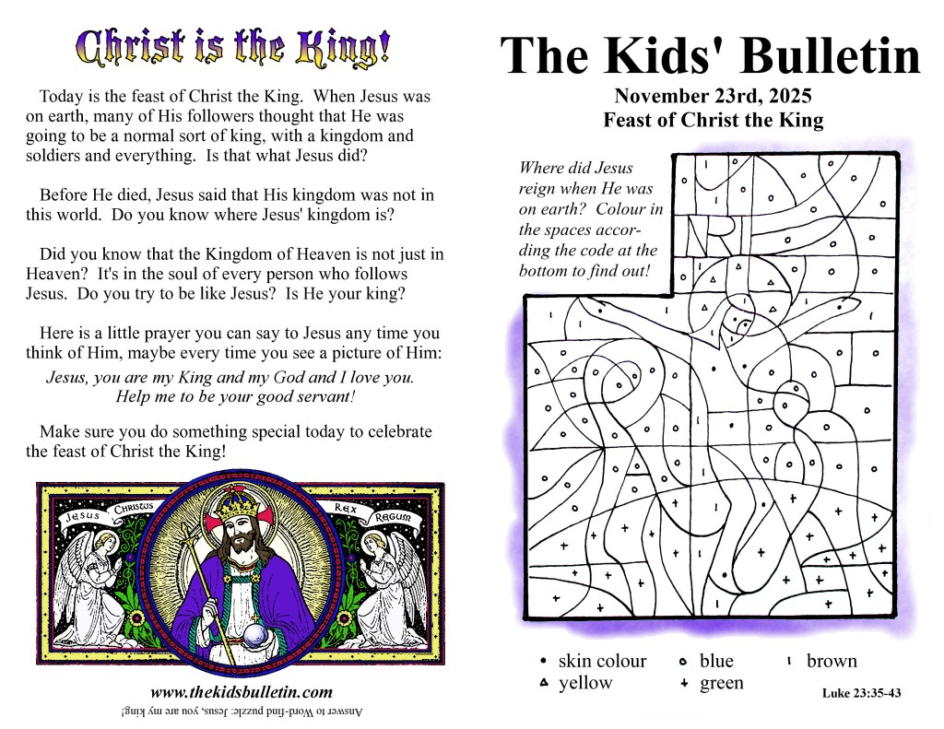
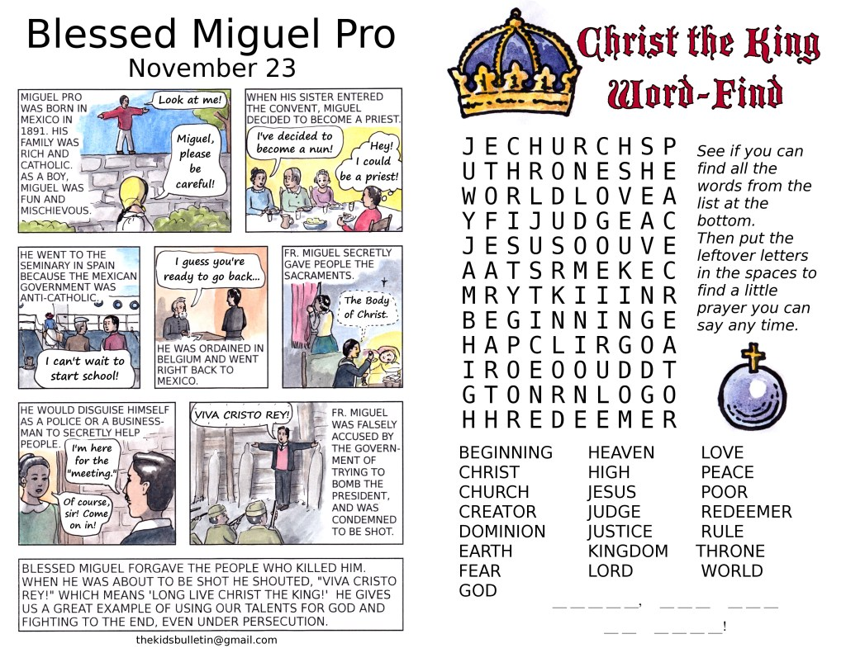

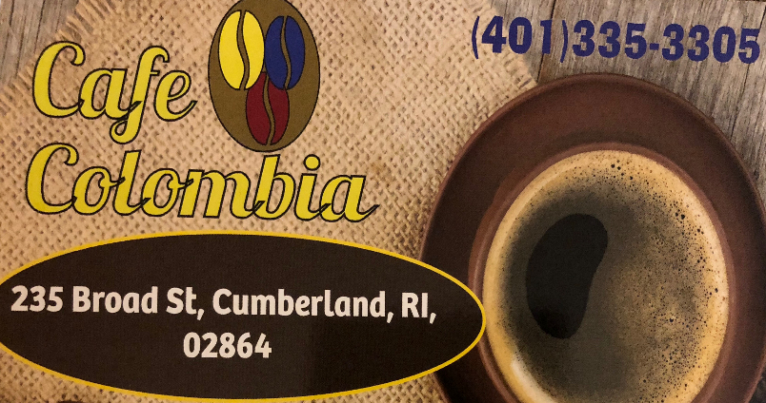
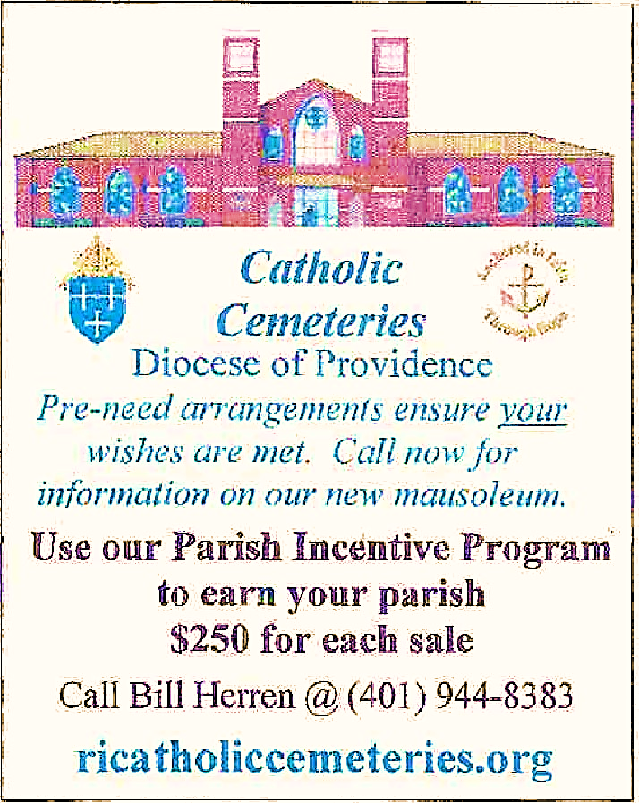

479 Mineral Spring Avenue, Pawtucket, RI 02860
Diana Zuleta, Manager
www.elpaisa.com
outside Patio for dining and all your special events



Learn More about Advertising
in Your Parish Bulletin
Call us at 722-9054
or email us at st.johnthebaptist@verizon.net
• SUPPORT YOUR PARISH
• REACH NEW CUSTOMERS



401-617-3287

Please remember to support our Bulletin Advertisers!
¡Por favor, recuerde apoyar a los que patrocinan el Boletín!

ence Preferred

Giving on line
Scan the QR Code to make your
digital donation to the Church.
Escanea el Código para
hacer tu donación digital a la
Iglesia

ence Preferred

