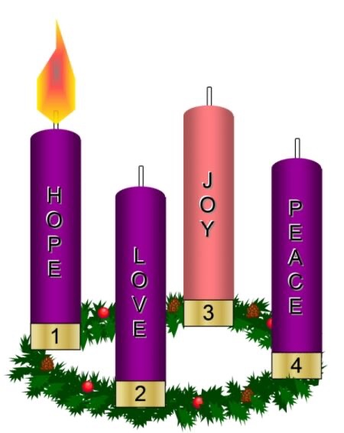
Saint John the Baptist Parish Parroquia San Juan Bautista
The Destruction of the Temple and Signs of the End Times
Luke 21:5-19
69 QUINCY AVE., PAWTUCKET, RI 02860
Rev. Mauricio Romero Víquez, Pastor
Vicente Caban, Deacon
Robert Giambo, Organist
Mrs. Cecilia Marín-Hoyt, Secretary
Email stjohnbaptist.org@gmail.com www.churchofstjohnthebaptist.org

Office Hours
Horario de la Oficina
Monday – Thursday / Lunes a Jueves
9:00am - 2:00pm 401-722-9054

Weekend Masses
Misas de fin de semana
Saturday: 4:30pm English / Inglés
Sábado 6:00pm Español / Spanish
Sunday: 9:30am English / Inglés
Domingo 11:30am Español / Spanish

Daily Masses
Misas durante la semana
Wednesday 8:00am English / Inglés
Martes y Viernes 7:00pm Español / Spanish
Bilingual Mass Saturday / Sábado at 8:00am

Confessions (Chapel) / Confessions (Capilla)
Saturday / Sábado 3:30pm to 4:20pm
& 5:30pm to 5:50pm or by apt. / por cita

Baptism / Bautismo
Baptisms are celebrated on the second Sunday of every Month after the 11:30am Mass. Please call the rectory at least two months in advance.
Los Bautismos se celebran el segundo Domingo de cada mes después de la Misa de las 11:30am. Llame a la rectoría con 2 meses de anticipación.

Anointing of the Sick
Unción de los enfermos
Please call the parish.
Por favor llamar a la parroquia.

Legión de María
Lunes a las 6:00pm en la Sacristía
Matrimony / Matrimonio
Call one year in advance to begin preparation. Llamar con un año de anticipación.

Eucharistic Adoration
Adoración Eucarística
Every Friday / Todos los Viernes
9:00am to 6:45pm in the Church / en la Iglesia

Young Women’s Faith Group
Ages / Edades 15 to 25
Meeting Place: Rectory
1st Sunday of the month from 6-8pm

Chiquitin Misionero
Wednesdays / Miercoles 6 – 7:30pm
5 to 7 years old / Niños de 5 a 7 años

Comunidad Evangelizadora (CERS)
Miércoles a las 7:30pm en el sótano

Food Bank / Banco de Comida
December / Diciembre
Monday / Lunes 22 & 29
9:30am to 11:00am & 6:00pm to 7:00pm
Wednesday / Miercoles 24 &31
9:30am to 11:00am

Hospitality House / Casa de Hospitalidad
Open every Tuesday / Martes at 10:30am
Hot lunch / Almuerzo caliente at 11:30 am

New Parishioners
Please call the Rectory to register.
Llamar a la Rectoría para registrarse.
Dear Parishioners,
Happy and Blessed First Sunday of Advent! The season of Advent begins a new liturgical year in
the Catholic Church. Therefore, it is a great time for each of us to “begin again” as we spiritually
prepare to celebrate the Birth of Jesus on Christmas Day, as well as prepare each day to welcome
Jesus Christ into our lives. Here are “Ten Ways to Get More out of Advent” by
Lorene Hanley Duquin (10/7/2013): “(1) Reect on Advent as a time of
Dear Parishioners,
Happy and Blessed First Sunday of Advent! The season of Advent begins a new liturgical year in
the Catholic Church. Therefore, it is a great time for each of us to “begin again” as we spiritually
prepare to celebrate the Birth of Jesus on Christmas Day, as well as prepare each day to welcome
Jesus Christ into our lives. Here are “Ten Ways to Get More out of Advent” by
Lorene Hanley Duquin (10/7/2013): “(1) Reect on Advent as a time of
brothers and sisters, may this season of Advent be fruitful for each one of us. God Bless!
Fr. Sistare
IMPORTANT NOTE: During this time of A
Dear Parishioners,
Happy and Blessed First Sunday of Advent! The season of Advent begins a new liturgical year in the Catholic Church. Therefore, it is a great time for each of us to “begin again” as we spiritually prepare to celebrate the Birth of Jesus on Christmas Day, as well as prepare each day to welcome Jesus Christ into our lives. Here are “Ten Ways to Get More out of Advent” by Lorene Hanley Duquin (10/7/2013): “(1) Reflect on Advent as a time of waiting. The idea of waiting is not popular in our culture of instant gratification, but it creates in us a new kind of self-discipline that helps us to appreciate the present moment and look to the future with peaceful anticipation. (2) Turn your breathing into a prayer. Take a few deep breaths throughout the day and imagine that God's love is flowing through you to every part of your body. As you exhale, let go of tension, worry and anything else that is not of God. (3) Long for the Lord. Make it a habit of silently praying, "Come, Lord Jesus.” (4) Unite with Mary. Set aside time once a day to join Our Lady in praying the Canticle of Mary (see Lk 1:46-55). (5) Do something nice for someone every day. It might be an encouraging word, a phone call, a note of appreciation or a little act of kindness. (6) Get rid of grudges. Use Advent as an opportunity to let go of any anger or resentment that you might be holding onto. (7) Pray for patience. If you find yourself becoming anxious or upset, ask the Lord for the gift of patience. Then make a conscious effort to be a more patient person. (8) Offer up something painful or difficult in your life. The best way to transform trials and tensions is to turn them into a prayer. (9) Receive the Sacrament of Reconciliation. Take advantage of the opportunity to cleanse your soul in preparation for the coming of Jesus. (10) Think about the special gifts and talents God has given you. How are you using these gifts?” My brothers and sisters, may this season of Advent be fruitful for each one of us. God Bless!
Fr. SistaDear Parishioners,
Happy and Blessed First Sunday of Advent! The season of Advent begins a new liturgical year in the Catholic Church. Therefore, it is a great time for each of us to “begin again” as we spiritually prepare to celebrate the Birth of Jesus on Christmas Day, as well as prepare each day to welcome Jesus Christ into our lives. Here are “Ten Ways to Get More out of Advent” by Lorene Hanley Duquin (10/7/2013): “(1) Reflect on Advent as a time of waiting. The idea of waiting is not popular in our culture of instant gratification, but it creates in us a new kind of self-discipline that helps us to appreciate the present moment and look to the future with peaceful anticipation. (2) Turn your breathing into a prayer. Take a few deep breaths throughout the day and imagine that God's love is flowing through you to every part of your body. As you exhale, let go of tension, worry and anything else that is not of God. (3) Long for the Lord. Make it a habit of silently praying, "Come, Lord Jesus.” (4) Unite with Mary. Set aside time once a day to join Our Lady in praying the Canticle of Mary (see Lk 1:46-55). (5) Do something nice for someone every day. It might be an encouraging word, a phone call, a note of appreciation or a little act of kindness. (6) Get rid of grudges. Use Advent as an opportunity to let go of any anger or resentment that you might be holding onto. (7) Pray for patience. If you find yourself becoming anxious or upset, ask the Lord for the gift of patience. Then make a conscious effort to be a more patient person. (8) Offer up something painful or difficult in your life. The best way to transform trials and tensions is to turn them into a prayer. (9) Receive the Sacrament of Reconciliation. Take advantage of the opportunity to cleanse your soul in preparation for the coming of Jesus. (10) Think about the special gifts and talents
Dear Parishioners,
Happy and Blessed First Sunday of Advent! The season of Advent begins a new liturgical year in the Catholic Church. Therefore, it is a great time for each of us to “begin again” as we spiritually prepare to celebrate the Birth of Jesus on Christmas Day, as well as prepare each day to welcome Jesus Christ into our lives. Here are “Ten Ways to Get More out of Advent” by Lorene Hanley Duquin (10/7/2013): “(1) Reflect on Advent as a time of waiting. The idea of waiting is not popular in our culture of instant gratification, but it creates in us a new kind of self-discipline that helps us to appreciate the present moment and look to the future with peaceful anticipation. (2) Turn your breathing into a prayer. Take a few deep breaths throughout the day and imagine that God's love is flowing through you to every part of your body. As you exhale, let go of tension, worry and anything else that is not of God. (3) Long for the Lord. Make it a habit of silently praying, "Come, Lord Jesus.” (4) Unite with Mary. Set aside time once a day to join Our Lady in praying the Canticle of Mary (see Lk 1:46-55). (5) Do something nice for someone every day. It might be an encouraging word, a phone call, a note of appreciation or a little act of kindness. (6) Get rid of grudges. Use Advent as an opportunity to let go of any anger or resentment that you might be holding onto. (7) Pray for patience. If you find yourself becoming anxious or upset, ask the Lord for the gift of patience. Then make a conscious effort to be a more patient person. (8) Offer up something painful or difficult in your life. The best way to transform trials and tensions is to turn them into a prayer. (9) Receive the Sacrament of Reconciliation. Take advantage of the opportunity to cleanse your soul in preparation for the coming of Jesus. (10) Think about the special gifts and talents
Dear Parishioners,
The season of summer is officially underway, as we can tell with the higher
temperatures outside. The following beautiful reflection and summer prayer can
help us reflect on how important our relationship with the Lord should be every
day in our lives.
Summer Reflection
“All of us have so much to be thankful for each day. When we awake to a new day,
when a friend is in touch with us, for the food we eat, for the water that flows into
our homes, for flowers, birds, trees, our health, for doctors close by who care for
us: the list can go on and on. Thanking God should be part of our daily lives. It is
also good to tell God about worries and concerns: about jobs, relationships,
family, health, whatever comes to mind. Sharing those thoughts with God will often
help to lessen the burdens we carry. Take time -- lots of it -- each day to talk to
God in prayer. If you spend time with family members or friends, engage them in
prayer with you, and listen to how they share their joys/concerns/thanks with
God.”
Summer Prayer
“Creator of all, thank You for summer! Thank You for the warmth of the sun and
the increased daylight. Thank You for the beauty I see all around me and for the
opportunity to be outside and enjoy Your creation. Thank You for the increased
time I have to be with my friends and family, and for the more casual pace of the
summer season. Draw me closer to You this summer. Teach me how I can pray no
matter where I am or what I am doing. Warm my soul with the awareness of Your
presence, and light my path with Your Word and Counsel. As I enjoy Your
creation, create in me a pure heart and a hunger and a thirst for You. Amen.”
Dear Parishioners,
The season of summer is officially underway, as we can tell with the higher
temperatures outside. The following beautiful reflection and summer prayer can
help us reflect on how important our relationship with the Lord should be every
day in our lives.
Summer Reflection
“All of us have so much to be thankful for each day. When we awake to a new day,
when a friend is in touch with us, for the food we eat, for the water that flows into
our homes, for flowers, birds, trees, our health, for doctors close by who care for
us: the list can go on and on. Thanking God should be part of our daily lives. It is
also good to tell God about worries and concerns: about jobs, relationships,
family, health, whatever comes to mind. Sharing those thoughts with God will often
help to lessen the burdens we carry. Take time -- lots of it -- each day to talk to
God in prayer. If you spend time with family members or friends, engage them in
prayer with you, and listen to how they share their joys/concerns/thanks with
God.”
Summer Prayer
“Creator of all, thank You for summer! Thank You for the warmth of the sun and
the increased daylight. Thank You for the beauty I see all around me and for the
opportunity to be outside and enjoy Your creation. Thank You for the increased
time I have to be with my friends and family, and for the more casual pace of the
summer season. Draw me closer to You this summer. Teach me how I can pray no
matter where I am or what I am doing. Warm my soul with the awareness of Your
presence, and light my path with Your Word and Counsel. As I enjoy Your
creation, create in me a pure heart and a hunger and a thirst for You. Amen.”
Dear Parishioners,
The season of summer is officially underway, as we can tell with the higher
temperatures outside. The following beautiful reflection and summer prayer can
help us reflect on how important our relationship with the Lord should be every
day in our lives.
Summer Reflection
“All of us have so much to be thankful for each day. When we awake to a new day,
when a friend is in touch with us, for the food we eat, for the water that flows into
our homes, for flowers, birds, trees, our health, for doctors close by who care for
us: the list can go on and on. Thanking God should be part of our daily lives. It is
also good to tell God about worries and concerns: about jobs, relationships,
family, health, whatever comes to mind. Sharing those thoughts with God will often
help to lessen the burdens we carry. Take time -- lots of it -- each day to talk to
God in prayer. If you spend time with family members or friends, engage them in
prayer with you, and listen to how they share their joys/concerns/thanks with
God.”
Summer Prayer
“Creator of all, thank You for summer! Thank You for the warmth of the sun and
the increased daylight. Thank You for the beauty I see all around me and for the
opportunity to be outside and enjoy Your creation. Thank You for the increased
time I have to be with my friends and family, and for the more casual pace of the
summer season. Draw me closer to You this summer. Teach me how I can pray no
matter where I am or what I am doing. Warm my soul with the awareness of Your
presence, and light my path with Your Word and Counsel. As I enjoy Your
creation, create in me a pure heart and a hunger and a thirst for You. Amen.”

First Sunday of Advent
November 30, 2025

Peace and Blessings, dear brothers and sisters in our Lord Jesus Christ.
Last Sunday we celebrated the Solemnity of Our Lord Jesus Christ, King of the Universe (34th Sunday), and with it we concluded the liturgical year, Cycle C, praying like the good thief: “Lord, when you come into your Kingdom, remember me” (Lk 23:43).
Today we begin a new liturgical year, Cycle A, and with it the Season of Advent opens before us—one of the most beautiful and meaningful times of our Christian journey. These four weeks invite us to prepare our hearts to welcome the Lord who comes—not only in the joyful remembrance of His birth in Bethlehem, but also in His daily coming into our lives and His glorious return at the end of time.
Advent is therefore a time of active hope, of watchfulness and conversion. The Word of God this Sunday—with the prophetic voice of Isaiah, the exhortation of Saint Paul, and Jesus’ call to “stay awake” (Mt 24:42)—places us before the urgency of waking up, of opening our eyes to what truly matters. This is the spirit of Advent: to remain attentive to the Lord’s coming with faith, joy, and renewed hope.
The first reading (Isaiah) offers a vision of many peoples walking toward Jerusalem in search of lasting peace. How necessary it is that this Word take flesh in a world marked by global conflict (Israel–Gaza, Russia–Ukraine). The prophet speaks—indeed, dreams—of a Jerusalem that must be wise: one that dares to transform swords into plowshares and spears into pruning hooks. This choice for peace and not for war is, for the prophet, a divine choice—there is no doubt!
Brothers and sisters, Advent invites us, Sunday after Sunday as we light the candles of our Advent wreath, to walk in the light of the Lord (Is 2:5) and to long for peace.
In the second reading, Saint Paul (Romans) proclaims with strength: “It is now the hour for you to wake from sleep… The night is far gone; the day is at hand” (Rom 13:11–12).
The “day” Paul speaks of is not simply a poetic image but the Day of the Lord, the decisive moment when Christ will be fully revealed. But that day begins here and now—every time we welcome His presence in our hearts, in the Eucharist, in immigrants seeking a better

life for their families, and in the Word that transforms us. Advent therefore looks not only to the future but also to the present: Christ comes now, in the midst of history, in what is small and ordinary (a newborn Child). To “put on the Lord Jesus Christ” is to live the Gospel—an expression rich in theology—inviting us to change the direction of our lives and the way we understand God.
Let us remember that Saint Augustine’s life changed radically when he read this passage from Romans: “Put on the Lord Jesus Christ” (Rom 13:14a). These words deserve to awaken conversion. Neither rhetoric nor mystical cults could fill his heart. It was Christ Jesus, through an experience of deep interiority, who transformed the meaninglessness of Augustine’s former life.
The key theme of today’s Gospel (Matthew) is watchfulness and discernment.
Watchfulness, because the Christian must remain alert so as not to fall into the routine of daily life. The Gospel warns us: “As it was in the days of Noah, so will it be at the coming of the Son of Man. Before the flood, people were eating, drinking, and marrying… and they did not know until the flood came and swept them all away” (Mt 24:37ff).
And discernment, because we must distinguish between fear of world chaos (wars and natural disasters) and the true coming of the Lord. How? The Gospel gives the key in the invitation: “Stay awake and be prepared, for you do not know on which day your Lord will come” (Mt24:42).
This means being attentive and discerning the signs of the times—as the Second Vatican Council teaches—through the light of the Gospel, not through fear of the events around us.
Advent offers us four weeks to re-orient the heart.
Each candle we light on the wreath is a reminder of the light Christ desires to ignite in us. Each reading, each hymn, each prayer is an invitation to allow His coming to renew us from within.

For Personal Reflection
- How am I preparing for this time of Advent?
Have I prepared my Advent wreath? Have I set aside a day of retreat to enter this season of hope?
- How do I want to live Advent this year?
Take a few minutes to ask yourself what you did last year. Did you focus only on Christmas shopping, trips, or food?
And how do you desire to live this holy season of Advent this year?
I encourage you to be “a voice crying out in the desert” in our time, like our patron Saint John the Baptist, who exhorts us: “Prepare the way of the Lord” (Mk 1:3).
MASS INTENTIONS
Saturday November 29 4:30pm
+Nelson Carreiro & Joseph Placido
Sunday November 30 11:30am
For Intentions of Father Mauricio Romero Viquez
Wednesday December 3 8:00am
For the Members of the Dujardin Family
Saturday December 6 8:00am
For the Health of Wellbeing of Carmen Rivera
Vigil Mass 4:30pm
+ Dolores Robin
Sunday December 7 9:30am
+Maria, Adolfo, Zygmunt Szumilas

Collection 11/23 $4,436.00
Human Development Collection $1,502.00
Pies $365.00
Second Collection
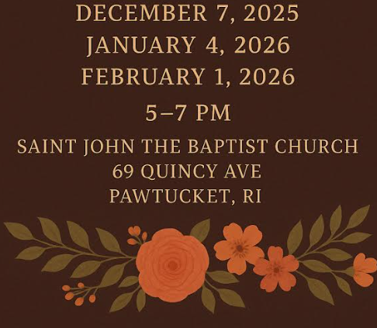
Retirement Fund for Religious 12/14
Fuel/Maintenance 12/28

Weekly Offering Envelopes
The weekly offering envelopes are now available. Beginning the weekend of December 6 and 7, you may pick them up before or after Mass. Members of the community will be available to assist you if you have any questions.

WE ASK FOR YOUR PRAYERS
For the following parishioners:
In the Hospital: Hope Fernandes
At Home: Jovina De Barros, & Roberto Mejía
Jeanne Jugan Residence: Florence Corneau
Grandview: Alberto De Barros

Saint Joseph’s Vigil Candle
For the Health of Father Sistare
By Jose De Barros


Make a gift affirming the sanctity of human life. Please fill the baby bottles with coins, cash or checks and return them to the church by November 27 & 28. The Baby Bottle Boomerang Campaign is used to fund Rhode Island’s Right to Life Services, a ministry that helps pregnant women, newborns and toddlers throughout R.I., with material needs, referrals, emer-gency baby food/formula, and with Ancora, a free mobile ultrasound pregnancy center. There will be a collection bin located in the back of the church for when you return the bottles.



Announcements
Masses on Wednesday and Saturday 8am will now be celebrated in the Chapel. The donation is $10 on weekdays and $20 on weekends for each Mass.

Faith Formation Class Schedule
December 3, 10, 17 – Class
Time 6:00 to 7:30pm
In the Church Hall, please enter thru Bullock St.

The Installation Mass
It will take place on November 30th at 11:30am. It will be a bilingual Mass. There will be no 9:30am Mass. The intention will be for the needs of our new pastor, Father Mauricio Romero Víquez.

St. John the Baptist Parish Christmas Bazaar
The Christmas Bazaar will take place in the parish hall on Saturday, December 6, from 10am to 7pm and Sunday December 7, from 10:00am to 2:00pm (ticket sales end at 1:45 pm on Sunday The bazaar will feature raffles, food, plants, jewelry, baked goods, personalized t-shirts, themed raffle baskets, and much more. The venue is not accessible to people with disabilities.

Haga un regalo que afirme la santidad de la vida humana. Por favor, llene las botellas de bebe con monedas, efectivo o cheques y devuélvalas a la iglesia antes del 27 y 28 de noviembre. La Campaña Baby Bottle Boomerang se utiliza para financiar los Servicios de Derecho a la Vida de Rhode Island, un ministerio que ayuda a las mujeres embarazadas, recién nacidos y niños pequeños en todo Rhode Island, con necesidades materiales, referencias, alimentos/fórmula de emergencia para bebés, y con Ancora, un centro de embarazo con ultrasonido móvil gratuito. Habrá un contenedor de recolección ubicado en la parte trasera de la iglesia para cuando devuelva las botellas.

Saint John the Baptist Parish Raffle
Prizes
1st: $500 2nd: $250
3rd: $150 4th: $100
Drawing will take place during the Christmas Bazaar December 6 & 7
$5.00 Each Ticket

Anuncios

Las Misas de los miércoles y sábados 8am se celebrarán en la Capilla. La donacion es de $10 entre semana y $20 el fin de semana por cada Misa.

Horario de Clases de Formación de Fe
Diciembre 3, 10, 17 - Hay clase
De las 6:00 a las 7:30pm En el sótano de la Iglesia, entrar por la calle Bullock.

Novena de la Virgen de Guadalupe
Del 4 al 11 de Diciembre
a las 6:00pm en la Iglesia

Bazar Navideño de la Parroquia de
San Juan Bautista
El bazar navideño tendrá lugar en el salón parroquial el sábado 6 de diciembre, de 10:00am a 7:00pm, y el domingo 7 de diciembre, de 10:00am a 2:00pm (la venta de boletos finaliza a la 1:45 del domingo). En el bazar habrá rifas, venta de comida, plantas, joyería, repostería, camisetas personalizadas, cestas temáticas para rifas y mucho más. El local no es accesible para personas con discapacidad.

Celebración de Nuestra Señora de Guadalupe
La Misa diocesana a Nuestra Sra. de Guadalupe se llevará a cabo el viernes 12 de diciembre a las 7:00pm en la Catedral de San Pedro y San Pablo, el Celebrante y Homilista será Su Excelencia Reverendísima Bruce A. Lewandowski, C.Ss.R. Obispo de Providence. Comenzaremos 5:30 p.m. con el rezo del Rosario, habrá confesiones y una serenata a la Virgen previo a la Misa. ¡Pasa la voz, invita a tus familiares y amigos!

Curso de Discernimiento
Con el Padre Mauricio comenzando el Jueves 4, 11 y 18 de Diciembre a las 7:00pm en el sótano de la Iglesia

Parroquia de San Juan Bautista Rifa
Premios
1º: $500 2º: $250
3º: $150 4º: $100
El sorteo se llevará a cabo durante
el Bazar de Navidad – Diciembre 6 y 7 $5.00 cada boleta

Primer Domingo de Adviento
30 de Noviembre, 2025

¡Paz y Bien!, estimados hermanos y hermanas, en nuestro Señor Jesucristo.

El domingo pasado celebramos la solemnidad de Jesucristo Rey del Universo (Domingo XXXIV), y así concluimos con el año litúrgico, ciclo C, pidiendo a Jesús como el buen ladrón: “Señor, cuando llegues a tu Reino, acuérdate de mí” (Lc. 23, 43). Comenzamos hoy un nuevo año litúrgico, ciclo A, y con él se abre el tiempo de Adviento, una de las etapas más hermosas y significativas del camino cristiano. Cuatro semanas en las que la Iglesia nos invita a preparar el corazón para recibir al Señor que viene, no sólo en la memoria gozosa de su nacimiento en Belén, sino también en su venida diaria a nuestras vidas y en su retorno glorioso al final de los tiempos.

El Adviento es, por tanto, un tiempo de esperanza activa, de vigilancia y conversión. La Palabra de Dios de este domingo, con la voz profética de Isaías, la exhortación de San Pablo y el llamado de Jesús a “velar” (Mt. 24, 42), nos sitúa ante la urgencia de despertar, de abrir los ojos a lo esencial. Este es el espíritu del Adviento: vivir atentos a la venida del Señor, con fe, con alegría y con esperanza renovada.

La primera lectura (Isaías), nos ofrece una visión de numerosos pueblos que caminan hacia Jerusalén, en busca de la paz duradera. ¡Cuánto es necesario que está palabra cobre vida!, en un mundo de tantos conflictos globales (Israel - Gaza, Rusia - Ucrania). Por eso el profeta nos habla (sueña más bien) de una Jerusalén que debe ser sabia: la que se atreva a hacer de las espadas arados y de las lanzas podaderas. Esta opción por la paz y no por la guerra es, para el profeta, una opción divina ¡no hay duda! Hermanos el Adviento, nos invita domingo con domingo, al encender las velas de nuestra corona de Adviento, a caminar bajo la luz del Señor (Is. 2, 5) y por ende anhelar la paz.

En la segunda lectura de San Pablo (Romanos), resuena con fuerza: “Ya es hora de despertarnos del sueño… La noche está avanzada, el día se acerca” (Rom. 13, 11-12). El “día” del que habla Pablo no es una metáfora poética, sino el día del Señor, el momento definitivo en que Cristo se manifestará en plenitud.

Pero ese día comienza ya aquí, cada vez que acogemos su presencia en el corazón, en la Eucaristía, en los inmigrantes que buscan una mejor calidad de vida para sus familias y en la Palabra que nos transforma. Por eso el Adviento no mira sólo hacia el futuro, sino también al presente: Cristo viene ahora, en medio de la historia, en lo pequeño y cotidiano (un niño recién nacido). Y revestirse del Señor Jesús es vivir en el proyecto del evangelio (revestirse de Cristo es toda una expresión teológica), que nos invita a cambiar de rumbo en la existencia y los planteamientos que tenemos de Dios.

Recordemos que San Agustín le cambió su vida radicalmente al leer esta carta de San Pablo a los Romanos: “revistasen del Señor Jesús” (Rom. 13, 14a). Son palabras que bien merecen una conversión. Ni la retórica ni los cultos mistéricos pudieron llenar su corazón. Fue Cristo Jesús, en esa experiencia de "interioridad", quien cambió una vida sin sentido de San Agustín.

La clave de lectura del evangelio de San Mateo, es vigilancia y discernimiento. Vigilancia por que el cristiano debe vigilar constantemente su vida, para no caer en la rutina de las cosas, así lo advierte el evangelio al decir: “Así como sucedió en tiempos de Noé, así también sucederá cuando venga el Hijo del hombre. Antes del diluvio, la gente comía, bebía y se casaba, hasta el día en que Noé entró en el arca. Y cuando menos lo esperaban, sobrevino el diluvio y se llevó a todos (Mt. 24, 37ss). Y discernimiento, por que el hombre debe separar el temor del caos mundial (guerras y catástrofes naturales), de la segunda venida del Señor ¿y cómo?, se hace esto, la clave la ofrece el evangelio con la invitación de “Velen, pues, y estén preparados, porque no saben qué día va a venir su Señor” (Mt. 24, 42). Es decir, estar atentos y discernir los signos de los tiempos, como lo dice el Concilio Vaticano II, bajo la luz del evangelio y no del temor de los acontecimientos que nos rodean.

El Adviento nos ofrece cuatro semanas para re-orientar el corazón. Cada vela que encendamos en la corona será un recordatorio de la luz que Cristo quiere encender en nosotros. Cada lectura, cada canto, cada oración, será una invitación a dejar que su venida nos renueve por dentro.

Para la reflexión personal

- ¿Cómo me preparó para este tiempo de Adviento?, es decir preparé mi corona de Adviento, ¿tomé algún día de retiro para iniciar este tiempo de esperanza?

- ¿Cómo deseo vivir el Adviento?, toma unos minutos para preguntarte que hiciste el año pasado ¿pensaste solo en compras navideñas, viajes o comida?, y cómo deseas vivir este año el santo Adviento.

Les ánimo a ser la voz en el desierto de nuestra época, como nuestro patrón San Juan Bautista, que nos exhortó: “preparar el camino para el Señor” (Mc. 1, 3).

INTENCIONES DE LAS MISAS
Sábado 29 de Noviembre Vigilia 8:00am
+Por todas las Almas del Purgatorio
+Antonio José Guerra Figueroa
Por la salud y bienestar de Carmen Rivera
Vigilia 6:00pm
+María Eugenia Hernández
+Adelfa Pérez
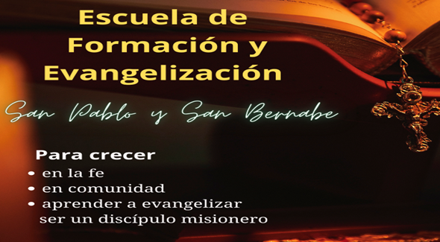
+Olga Zapata
+Antonio José Guerra Figueroa
Domingo 30 de Noviembre 11:30am
Por las intenciones del Padre Mauricio Romero
Martes 2 de Diciembre 7:00pm
+Antonio José Guerra Figueroa en su 40 aniversario
Viernes 5 de Diciembre 7:00pm
+Eterno descanso de Cecilia Vieira
+Por las Benditas Almas del Purgatorio
Sábado 6 de Diciembre (Misa Bilingüe) 8:00am
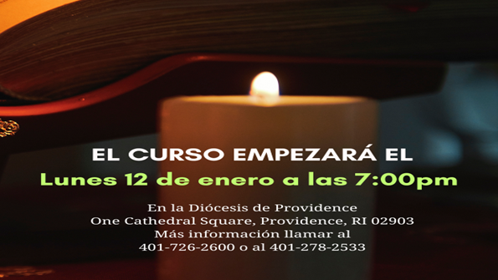
Por la sanación física y espiritual de Carmen Rivera
Vigilia 6:00pm
+Mirian y José Abner Giraldo
+Hernán Hernando Obregón
Domingo 7 de Diciembre 11:30am
+Por Almas del Purgatorio
+Antonio Monteiro
+Joa Jose Ramos
+Joana Soasa Leite
+Maria De Cruz Soasa
+Zayden Ruano Corado
+Margarita Ruiz de Rincon

Sobres para la Colecta semanal 2026
Los sobres para la colecta semanal ya están disponibles. A partir del fin de semana del 6 y 7 de Diciembre, podrán recogerlos antes o después de la misa.
Habrá miembros de la comunidad disponibles para asistirles si tienen alguna pregunta.

Colecta 11/23 $4,436.00
Desarollo Humano $1,502.00
Venta de Pie $365.00
Segunda Colecta Desarrollo Humano 11/23
Fondo de jubilación para religiosos 12/14
Gas/Mantenimiento 12/28

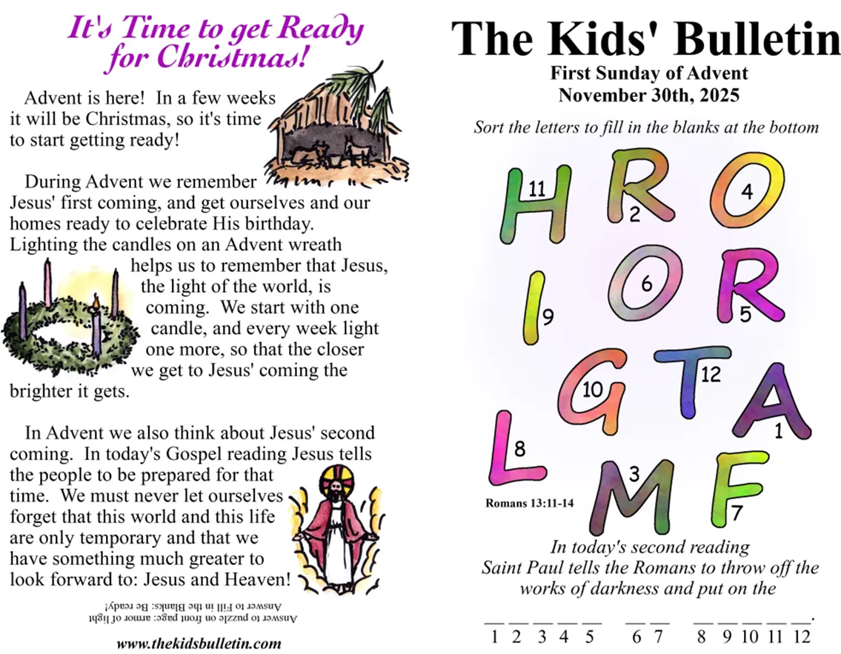
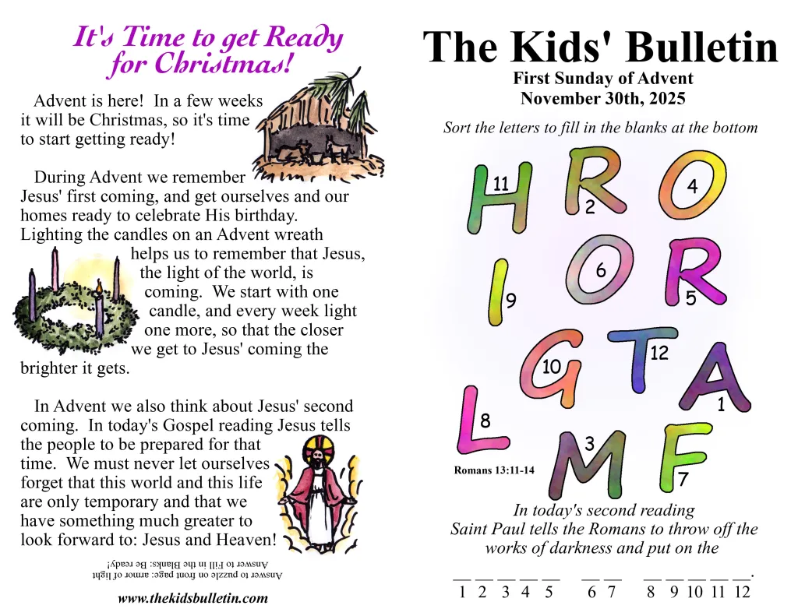
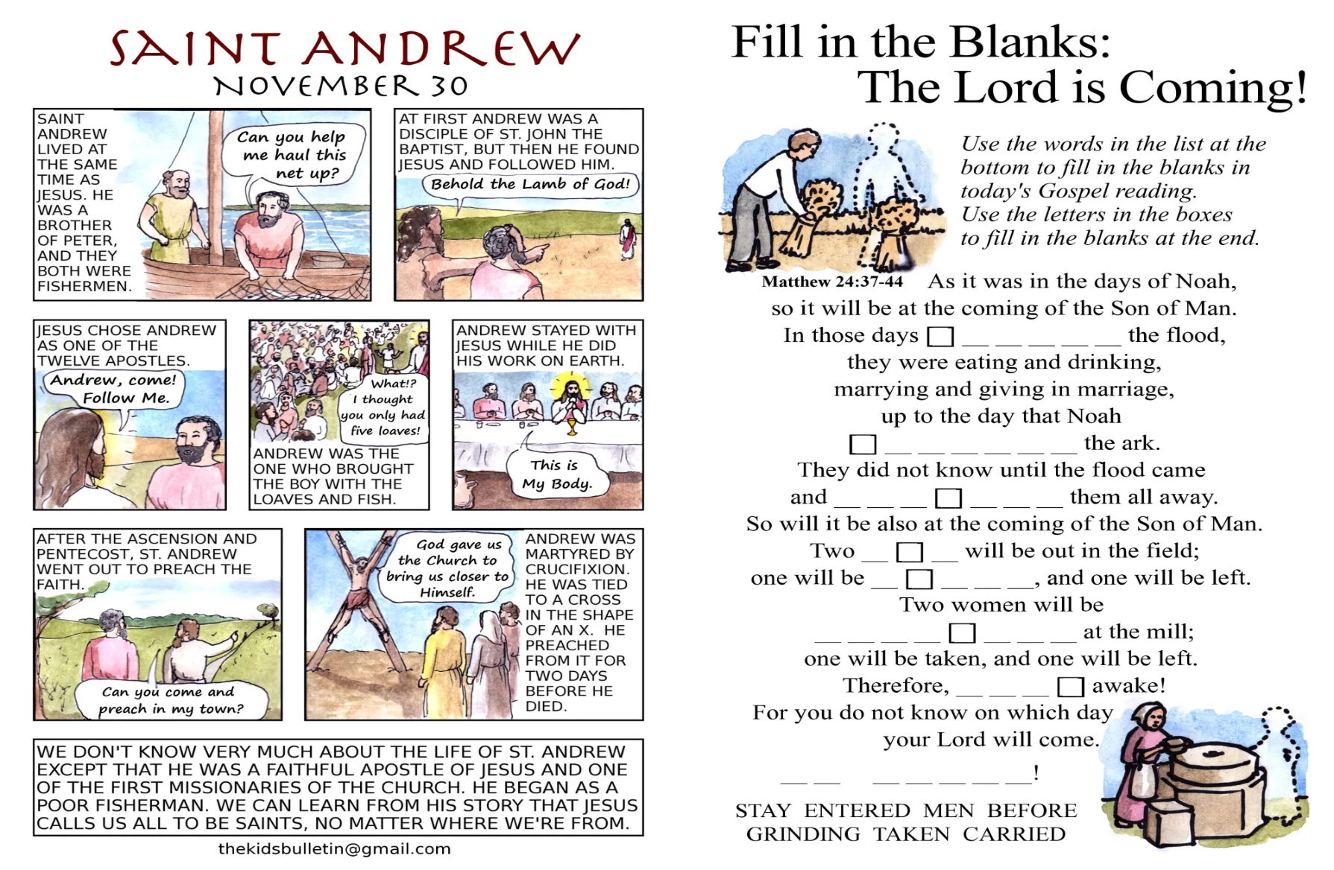


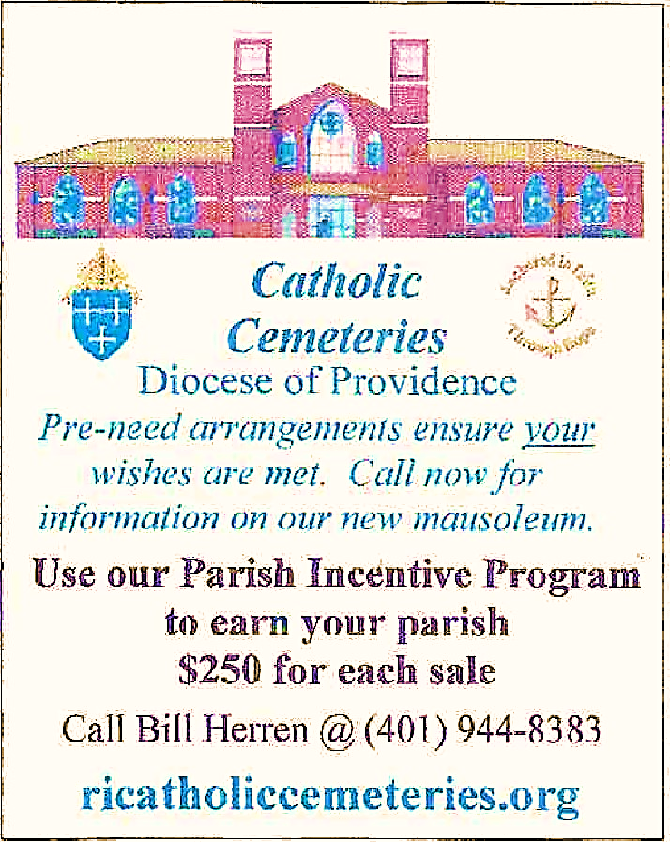

479 Mineral Spring Avenue, Pawtucket, RI 02860
Diana Zuleta, Manager
www.elpaisa.com
outside Patio for dining and all your special events



Learn More about Advertising
in Your Parish Bulletin
Call us at 722-9054
or email us at st.johnthebaptist@verizon.net
• SUPPORT YOUR PARISH
• REACH NEW CUSTOMERS



401-617-3287

Please remember to support our Bulletin Advertisers!
¡Por favor, recuerde apoyar a los que patrocinan el Boletín!

ence Preferred

Giving on line
Scan the QR Code to make your
digital donation to the Church.
Escanea el Código para
hacer tu donación digital a la
Iglesia

ence Preferred

